Figure 1. Profit before tax by banking segment — Q1FY27
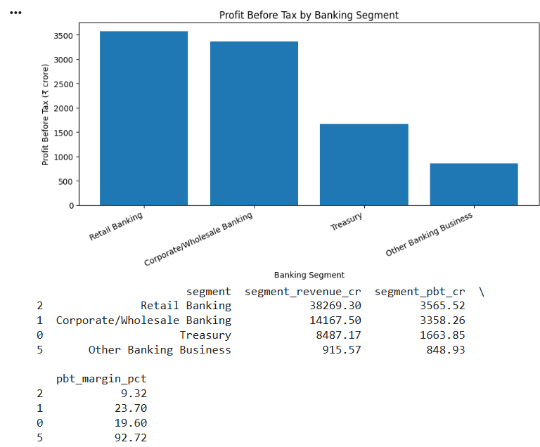

Retail Banking generates the highest profit among the segments, followed closely by Corporate/Wholesale Banking. However, Corporate/Wholesale Banking has a higher profit margin than Retail Banking. This shows that the segment generating the most profit does not necessarily have the highest profit margin.

PBT Margin=(Profit Before Tax​/Revenue)×100

Figure 2. Revenue growth versus Profit growth
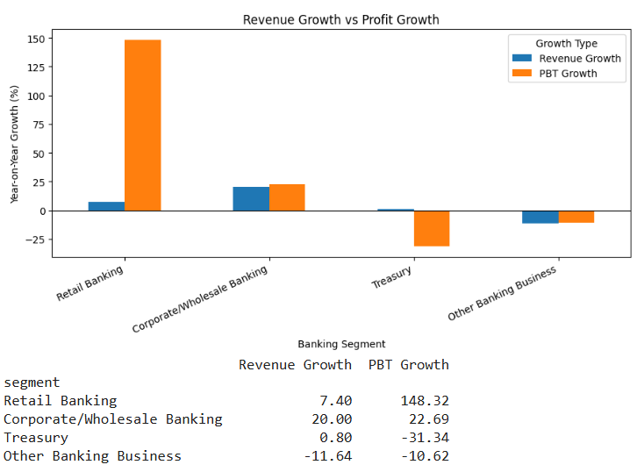
Retail Banking's profit has grown much faster than its revenue. Corporate/Wholesale Banking has also shown growth in both revenue and profit. In contrast, Treasury's profit has declined despite its revenue remaining almost unchanged. This shows that an increase in revenue does not always lead to an increase in profit.
Figure 3. Year-on-year loan growth by segment
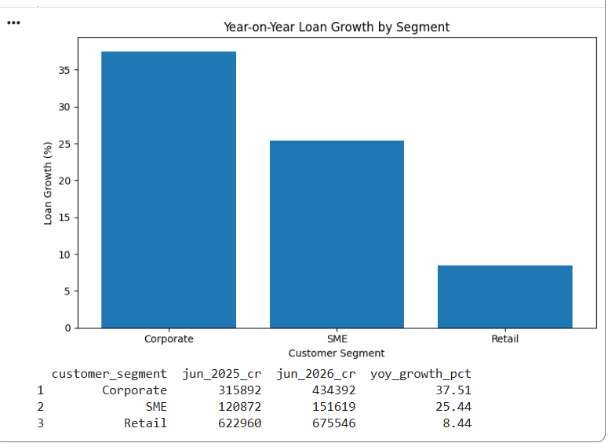

Corporate lending has grown the fastest followed by SME lending while Retail lending has grown at a slower pace. However, Retail continues to account for the largest share of the loan portfolio.
Figure 4. CASA versus term deposits
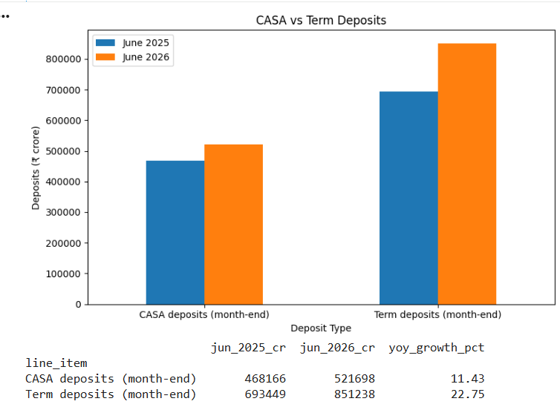

Both CASA and term deposits have increased, but term deposits have grown faster. This means that term deposits now account for a larger share of the bank's deposits, while CASA's share has declined. Since CASA is generally a lower-cost source of funds, this change in the deposit mix is worth considering when analysing the bank's profitability.

Figure 5. Net funding position by banking segment
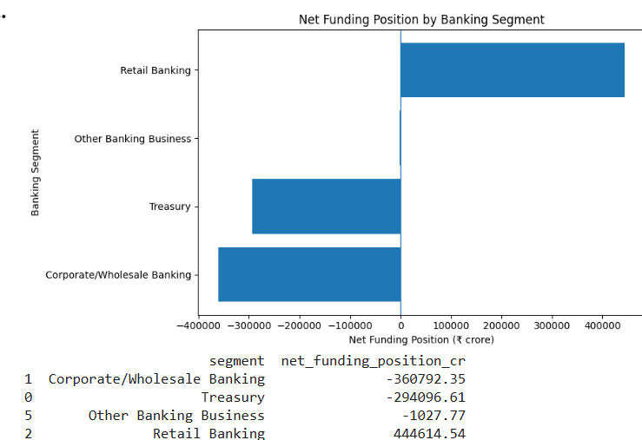

Retail Banking acts as a major source of funds for the bank, as its liabilities exceed its assets. In contrast, Corporate/Wholesale Banking and Treasury have more assets than liabilities, indicating that they use funds within the bank's overall funding structure. This highlights the different roles these segments play in deposit mobilisation and the use of funds.
Figure 6. Year-on-Year Growth in Income and Profit
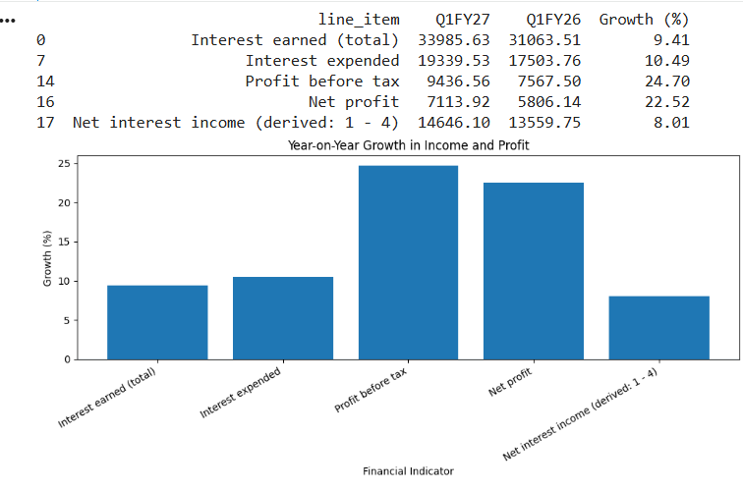
Interest earned grew, but interest expended grew slightly faster so net interest income rose by a smaller margin. Even so, profit before tax and net profit grew much faster than income. This shows that the sharp profit growth did not come from the core lending and deposit margin alone and that other factors, such as lower provisions played a bigger role.

Figure 7. Operating Cost and Provision Ratios
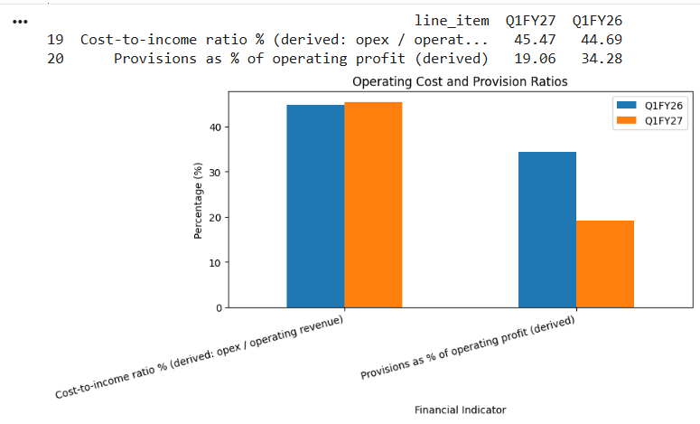
The cost-to-income ratio increased only slightly, which shows that operating costs stayed under control. The big change is in provisions, which took up a much smaller share of operating profit than a year ago. This lower provisioning burden is the main reason profit grew faster than income since more of the operating profit was left to flow into the bottom line.

Figure 8. Gross and Net NPA Ratios
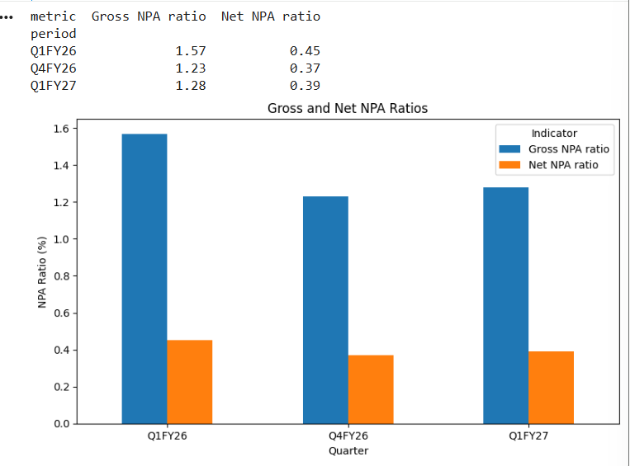
Asset quality is better than a year ago, as both gross and net NPA ratios have come down. Compared with the previous quarter there is a small rise but both ratios remain well below last year’s levels. Lower bad loans fit with the lower provisioning seen earlier and support the quality of the bank’s lending profits.

Figure 9. Segment Revenue vs Income from Operations
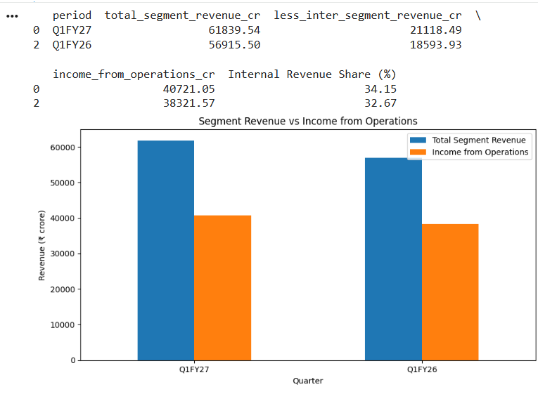

Total segment revenue grew faster than income from operations. The gap is inter-segment revenue, which is the revenue segments earn from each other within the bank and its share of total segment revenue has risen. Segment revenue therefore overstates what the bank actually earns from outside and segment-wise revenue figures should be read with this in mind.

